Game and Animation in Higher Diploma

Final year project

Initial report

Member list:

Lai ChinHok 210119313

SzeTo Wai 210097040

Wong WaiYin 210062762

Leung HueyChung 210435310

**Index**

1. Introduction
2. High Concept
3. Description of Topic
4. Concept Arts
5. Game Feature/ How to play
6. Research
7. Strength & Weak Analysis
8. Budget plan
9. Project plan schedule
10. Division of Labour

Introduction

First, the structure of our group is constituted by 3 animation stream’s students and a game stream’s student.

Depends on few programmer in our group, we decided to make a Japanese Role-Playing Game (JRPG). We would like to build an RPG game to lower work in programming. Oppositely, more illustrations and animations are decided to add in our game. But we still would like to make more different game features in our game. Effectiveness game play experience is brought by interesting game.

High Concept

A girl found out her memories, solve the problems that she has met, to escape (wake up) from the mental world.

Description of Topic

A girl lost her memories because of an incident. She needs to find out her memories in her mental world. There are two assistants, her sprites, are going to help her in her adventure. When she finds out all of memories her lost, she will wake up by her mental world.

Furthermore, different endings are affected by player choices.

Concept Art

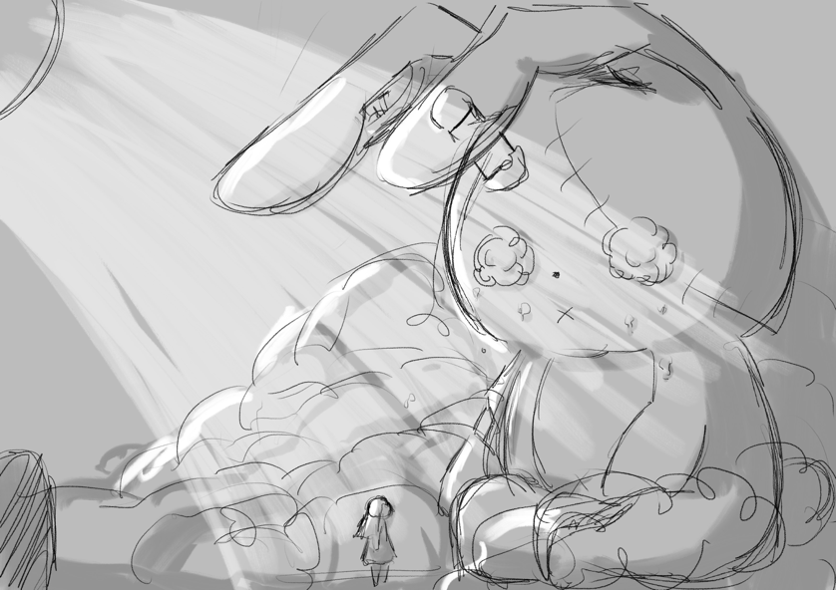

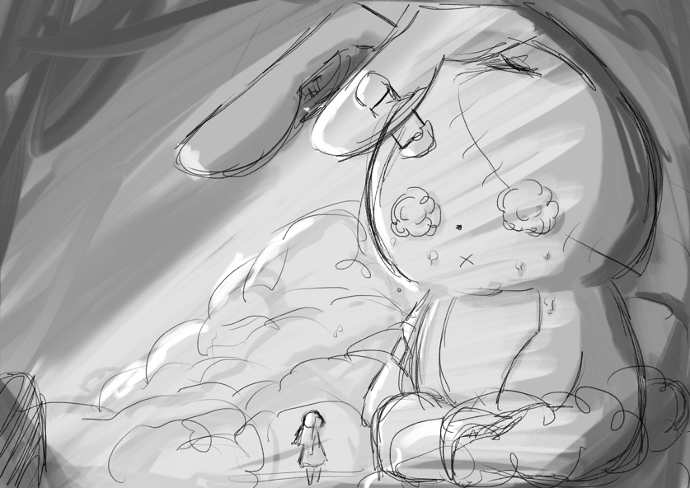

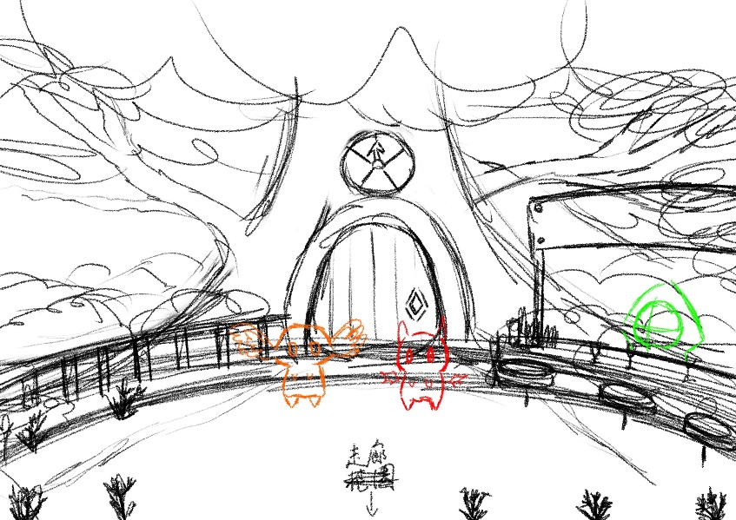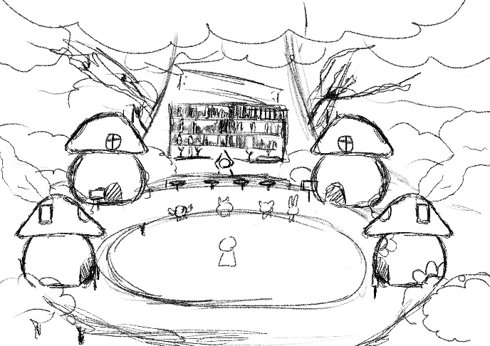

Game Features/ How to play

In normal RPG mode, player needs to press W, A, S, D to move and select.

Button E and esc can open the menu scene like Pokémon game. Player could check their items, map, character states, special power, option, and they can make saving in the menu scene.

Moreover, esc Key is also for back and cancelling.

Space bar (Key Enter) is for confirm and make conversation with NPC.

For the battle, player will meet enemies in their adventure. We would like to make different mini games for each type of enemies. And, of course, the boss battles will be different challenging games for each boss and story line.

Research

Scene

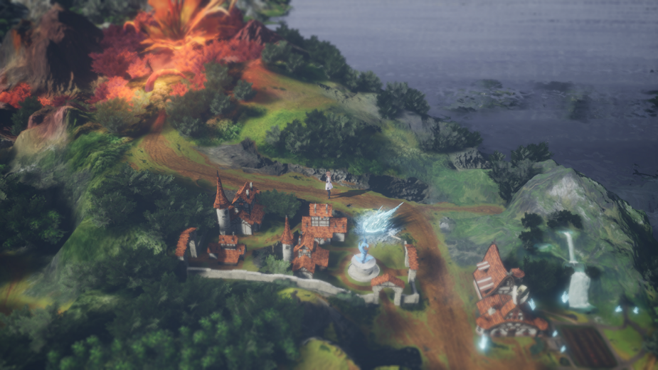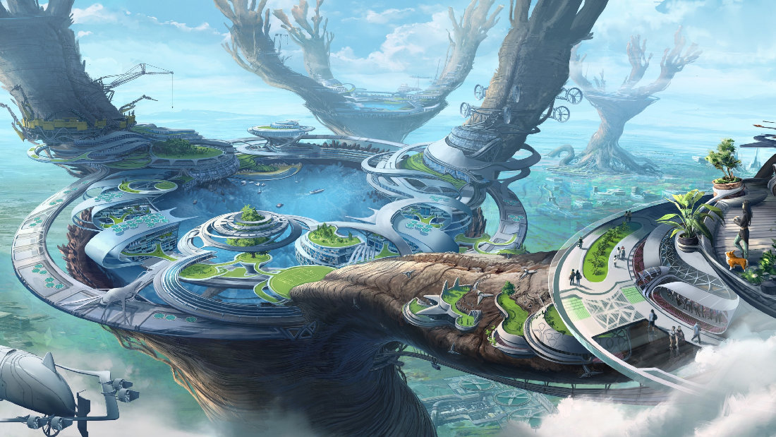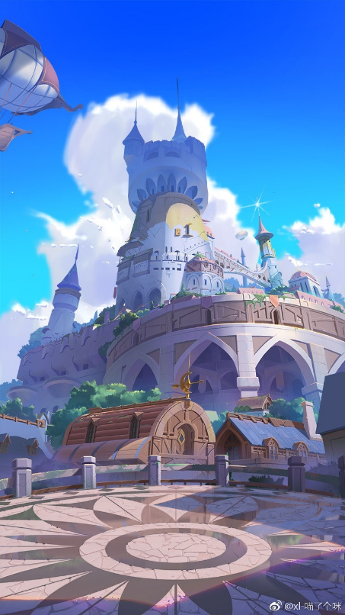

We decided to make garden, castle, and houses in the game.

There are some references for our scenes design on the above.

Character

Strength & Weak Analysis

Strengths:

* Different story lines
* Complete story
* Multiple game features
* Easy to control
* Challenging
* A lot of references for us

Weak:

* Too many similar games
* Single player
* If you want to play the game completely. It might take long time
* Low replayability
* A lot of illustration need to draw

Budget plan

$2,000 are preferred to buy some assets in the asset store by us. The average is $500 for each people.

Assets we would like to buy which is like the background music, sound effect, 2D models, textures and shaders etc.

Project plan schedule

We believe the basic game play can be made before mid-October.

For the demo game version, one story line will be completed, will be released at late October to early November. Which is including the illustrations and the ending animation.

END

Thank you